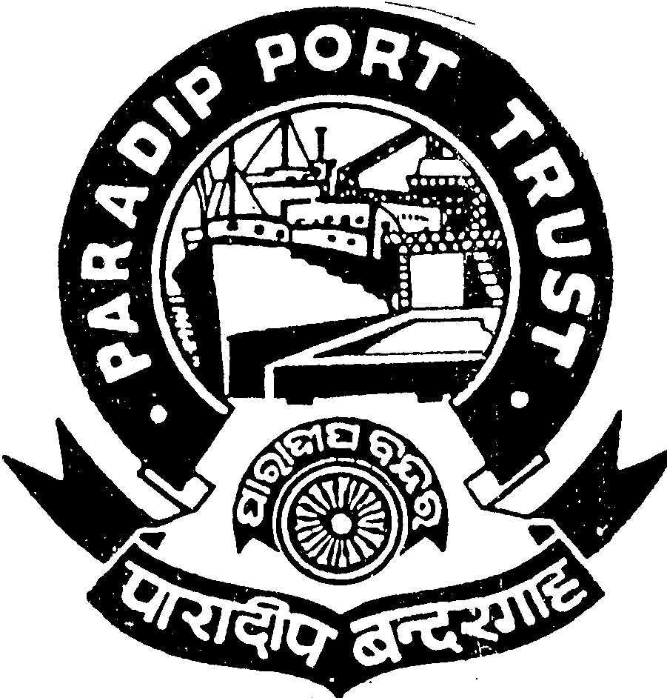PARADIP PORT TRUST
ADMINISTRATIVE DEPARTMENT
AT/PO: PARADIP PORT,
ORISSA – 754 142

No. AD/RSC-I-21/50/2010(Pt.II)/822 Dated, the 20th Feb, 2015
ADVERTISEMENT

Paradip Port Trust, an ISO-9001:2008 Certified Organisation invites applications from Indian Nationals for filling up of the following posts through direct recruitment which includes backlog vacancies for different categories to be recruited under Special Recruitment Drive as per the details given below.
Sl. No. | Post/scale of pay | UR | SC | ST | OBC | PH | Total | Age | Essential qualification & experience
01 | Junior Engineer (Civil)/  Rs. 19100-51100/- | 06 | 05 | 06 | 03 | 02 | 22 | 32 years | Diploma in Civil Engineering from a recognized institution.
02 | Junior Engineer (Mech)/  Rs. 19100-51100/- | 04 | 03 | 05 | 03 | 01 | 16 | 32 years | Diploma in Mechanical/  Auto mobile Engineering from a recognized institution
03 | Junior Engineer (Electrical)/  Rs. 19100-51100/- | 09 | 03 | 05 | 04 | 01 | 22 | 32 years | Diploma in Electrical/Electronics Engineering from a recognized institution.
04 | Junior Goods Clerk/  Rs. 17700-44600/- | 01 | 01 | - |  | - | 02 | 32 years | Graduate in any discipline. Candidates with 3 years experience in Port work having computer knowledge will be preferred.
05 | Out Door Clerk  Rs. 16300-38200/- | 07 | 07 | 05 | 09 | 03 | 31 | 32 years | Graduate with Diploma in Computer Application.
06 | Junior Engineer (Marine)/  Rs. 23600-56300/- | 02 | 01 | - | - | - | 03 | 35 years | 1. Must hold the certificate for 1st Class Engine Driver’s Exam under IV act.  2. Should have minimum 5 years post qualification experience in operation & maintenance of floating craft as 1st/2nd Class Engine Driver.  OR  1. Should pass in IME Exam under IV Act.  2. Should have minimum 2 years post qualification experience in operation & maintenance of floating craft as 1st class Driver (Marine).
GENERAL CONDITIONS
- Application complete in all respects in the prescribed format given herein-after and addressed to Secretary, Paradip Port Trust, Dist-Jagatsinghpur, Odisha- 754142 should reach the office of Secretary, Paradip Port Trust by registered post along with two self addressed envelopes, acknowledgement card etc by 31st March, 2015 Applicant must attach two latest passport size photographs indicating his/her name on the back side.
Contd. P/2

-2-
- The envelope containing the application should be clearly superscribed in BOLD capital letters with the post applied for and reservation category viz SC/ST/OBC/PH/UR as given below:-
APPLICATION FOR THE POST OF ………………& CATEGORY………………………….
- Separate application is to be sent for each post.
- Qualification of the candidates should be strictly in accordance with the prescribed qualification & experience .
- The cutoff date for determining the age is 01.02.2015.
- The upper age limit is relaxable as per Govt. guidelines. Age limit prescribed for applying for various posts will not apply in case of departmental candidates of PPT. Relaxation of age for the candidates enlisted under compassionate appointment scheme and who also are engaged on contract basis through formal method of recruitment will be as per Admn. Deptt. Office Order No. AD-RR-II-05-2011(Vol.IV)/4889 dated 29.11.2013. Relaxation of upper age limit in respect of workers engaged through contractors/co-operative societies/directly by PPT will be as per Admn. Deptt. Office Order No. AD-RR-II-18/2013/2167 dated 28/30th May, 2014. Physically handicapped candidates shall attach proof of updated Physical disability certificate.
- No request for change of any entries or part, originally indicated in the application form shall be entertained.
- The candidates shall be held responsible for correctness of all information given by him/her and in case of any information/documents found to be incorrect at a later stage; action shall be taken against the candidates including dismissal from service as per rule.
- Attested/Self attested true copies of proof of age/date of birth, academic/ professional qualification, caste certificate and experience etc. relating to the post advertised be attached with the applications and any document found unattested may lead to rejection of the application.
- No representation on any ground, for non-appearance for the test/interview etc. by the candidates will be entertained and his/her candidature will not be considered in such an eventuality.
- Persons already employed should send their applications through proper channel and have to produce ‘No Objection Certificate’ from their present employer at the time of interview.
- The candidate should not have been convicted by any Court of Law.
- Incomplete applications shall be summarily rejected.
- TA/DA will be admissible for attending tests/interview as per rule in shortest route for SC/ST candidates only.
- The candidates should note that PPT will in no case be responsible for non-receipt of their applications by PPT or any delay in receipts of call letters for written test/interview by the candidates or any reason whatsoever.
- Number of posts may increase or decrease.
- The candidates are advised to visit the website www.paradipport.gov.in for further instructions/directions/amendments etc. from time to time.
- The Appointing authority reserves the right to cancel selection process fully or partly without assigning any reason thereof.
- The recruitment/appointment will be subject to the result of the SLP No. 12319-12330 of 2012 for the post at Sl. No. 1 to 3 of the above table.
- Application should accompany a Demand Draft for Rs. 150/- (Rupees one hundred fifty) only drawn in favour of FA&CAO, PPT. (Fee is exempted for SC/ST/PH categories).
- There will be a written examination for each post. The candidates qualified in the written test will be called for personal interview/viva voice test.
- Persons with VH (Visually Handicapped) need not apply.
- Any dispute with regard to this recruitment will be subject to jurisdiction within the district of Jagatsinghpur.
- Decision of the Appointing Authority would be final, with regard to all matters connected with the recruitment.

Sd/-
Secretary
Paradip Port Trust

